-- create the database
create database bus_transport_system;
-- \c bus_transport_system;

-- create the route table
CREATE TABLE route ( route_no INT PRIMARY KEY, source CHAR(20), destination CHAR(20), no_of_stations INT );

-- create the bus table
create table bus (bus_no int primary key, capacity int not null depot_name varchar(20),route_no int references route(route_no));

-- create the driver table
CREATE TABLE driver ( driver_no INT PRIMARY KEY, driver_name CHAR(20), license_no INT UNIQUE, address CHAR(20), d_age INT, salary FLOAT );

-- create the bus_driver table to represent the many-to-many relationship between bus and driver
CREATE TABLE bus_driver ( bno INT, dno INT, dated DATE, shift VARCHAR(10), FOREIGN KEY (bno) REFERENCES bus(bus_no), FOREIGN KEY (dno) REFERENCES driver(driver_no) );

-- insert sample data into the route table
INSERT INTO route (route_no, source, destination, no_of_stations) VALUES (1, 'a', 'b', 5), (2, 'c', 'd', 7), (3, 'a', 'd', 10), (4, 'e', 'f', 6), (5, 'b', 'c', 8);

-- insert sample data into the bus table
INSERT INTO bus (bus_no, capacity, depot_name, route_no) VALUES (101, 50, 'central depot', 1), (102, 45, 'east depot', 2), (103, 60, 'central depot', 1), (104, 55, 'west depot', 3), (105, 50, 'south depot', 4);

-- insert sample data into the driver table
INSERT INTO driver (driver_no, driver_name, license_no, address, d_age, salary) VALUES (1, 'john smith', 12345, '123 main st', 35, 50000), (2, 'alice johnson', 23456, '456 oak ave', 40, 60000), (3, 'bob williams', 34567, '789 pine ln', 45, 70000), (4, 'mary brown', 45678, '246 elm st', 30, 55000), (5, 'david davis', 56789, '135 maple dr', 50, 80000);

-- insert sample data into the bus_driver table
INSERT INTO bus_driver (bno, dno, dated, shift) VALUES (101, 1, '2024-01-01', 'morning'), (101, 2, '2024-01-01', 'evening'), (102, 3, '2024-01-02', 'morning'), (103, 1, '2024-01-02', 'evening'), (104, 4, '2024-01-03', 'morning'), (105, 5, '2024-01-03', 'evening'), (101, 3, '2024-01-04', 'morning');
Output: 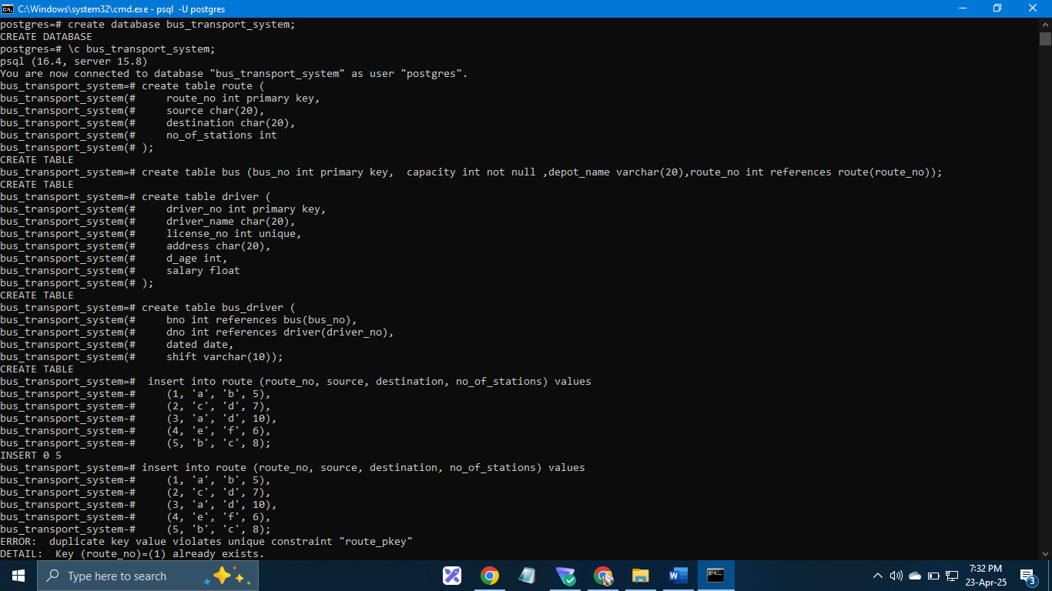
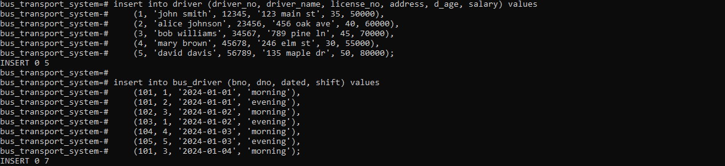

Questions :
-- a) pl/pgsql function to find the name of the driver having the maximum salary
create or replace function get_max_salary_driver()
returns text as $$
declare
max_salary_driver_name text;
begin
select driver_name into max_salary_driver_name
from driver
where salary = (select max(salary) from driver);
return max_salary_driver_name;
end;
$$ language plpgsql;

-- example usage:
-- select get_max_salary_driver();
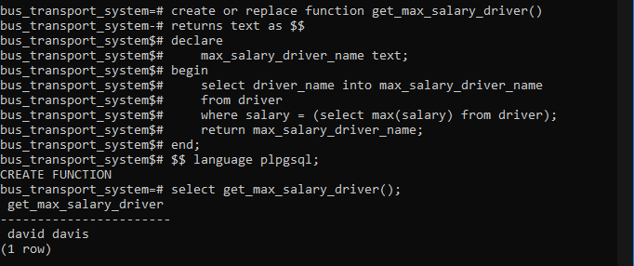

-- b) pl/pgsql function to accept bus_no and date and print its allotted driver name
create or replace function get_driver_name_for_bus_and_date(p_bus_no int, p_date date)
returns text as $$
declare
driver_names text ;
begin
select d.driver_name into driver_names
from driver d
join bus_driver bd on d.driver_no = bd.dno
where bd.bno = p_bus_no and bd.dated = p_date;

if driver_names = '' then
return 'no drivers found for the given bus and date.';
else
return driver_names;
end if;
end;
$$ language plpgsql;

-- example usage:
-- select get_driver_name_for_bus_and_date(101, '2024-01-01');
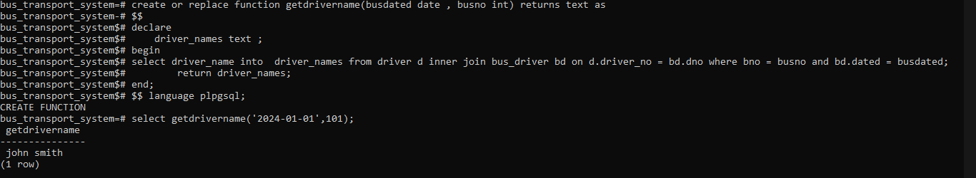

-- c) pl/pgsql function to change the destination for a given source
create or replace function replace_dest(routeno int,s text,d text ,cd text) returns text as
$$
begin
update route set destination = cd where route_no = routeno and source=s and destination=d ;
return cd;
end;
$$
language plpgsql;
select replace_dest(1,'a','b','e');
select * from route;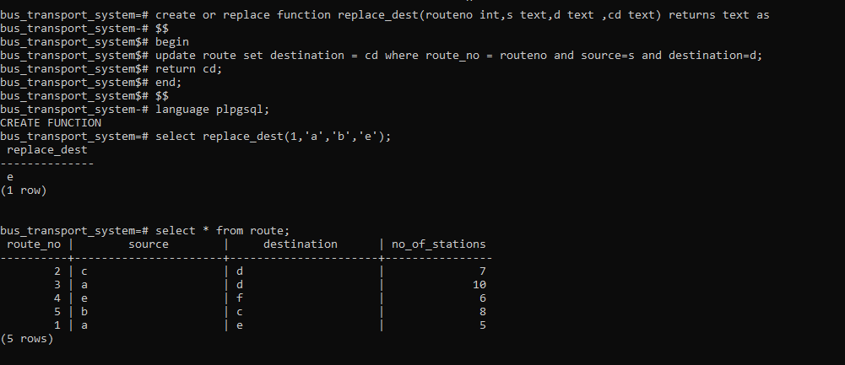

-- d) pl/pgsql function to accept driver number and remove his details from the database
create or replace function deletedriver(dn int) returns int as
$$
begin
delete from bus_driver where dno = dn;
delete from driver where driver_no = dn;
return dn;
end;
$$
language plpgsql;
`select deletedriver(5);
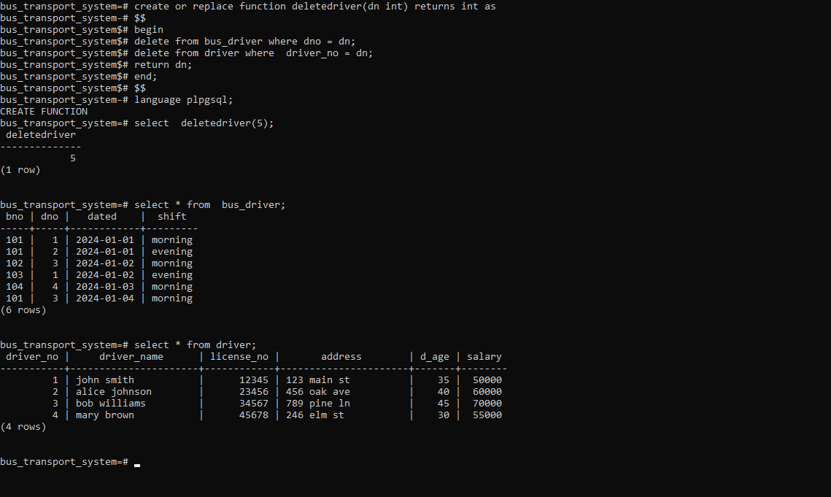

b.
-- create the database
create database business_trip_db;
-- \c business_trip_db;

-- create the dept table
create table dept (
deptno varchar(10) primary key,
dept_name char(20)
);

-- create the salesman table
create table salesman (
sno integer primary key,
s_name char(30),
start_year integer,
deptno varchar(10) references dept(deptno)
);

-- create the trip table
create table trip (
tno integer primary key,
from_city char(20),
to_city char(20),
departure_date date,
return_date date,
sno integer references salesman(sno)
);

-- create the expense table
create table expense (
eid integer primary key,
amount money,
tno integer references trip(tno)
);

-- insert data into dept
insert into dept (deptno, dept_name) values
('D1', 'Home appliances'),
('D2', 'Electronics'),
('D3', 'Clothing');

-- insert data into salesman
insert into salesman (sno, s_name, start_year, deptno) values
(101, 'Alice Smith', 2020, 'D1'),
(102, 'Bob Johnson', 2022, 'D1'),
(103, 'Charlie Brown', 2021, 'D2'),
(104, 'Diana Miller', 2023, 'D3'),
(105, 'Ethan Davis', 2019, 'D2');

-- insert data into trip
insert into trip (tno, from_city, to_city, departure_date, return_date, sno) values
(201, 'Pune', 'Mumbai', '2024-01-15', '2024-01-20', 101),
(202, 'Mumbai', 'Delhi', '2024-02-10', '2024-02-18', 102),
(203, 'Pune', 'Mumbai', '2024-03-01', '2024-03-05', 103),
(204, 'Delhi', 'Bangalore', '2024-04-12', '2024-04-20', 104),
(205, 'Mumbai', 'Pune', '2024-05-01', '2024-05-05', 101);

-- insert data into expense
insert into expense (eid, amount, tno) values
(301, 500.00, 201),
(302, 1200.00, 202),
(303, 750.00, 203),
(304, 1500.00, 204),
(305, 600.00, 205);

-- 1) function to display names of salesmen from ‘Home appliances’ department
create or replace function get_home_appliances_salesmen()
returns table (salesman_name char(30)) as $$
begin
return query
select s_name
from salesman
where deptno = (select deptno from dept where dept_name = 'Home appliances');
end;
$$ language plpgsql;

-- to call the function:
select * from get_home_appliances_salesmen();
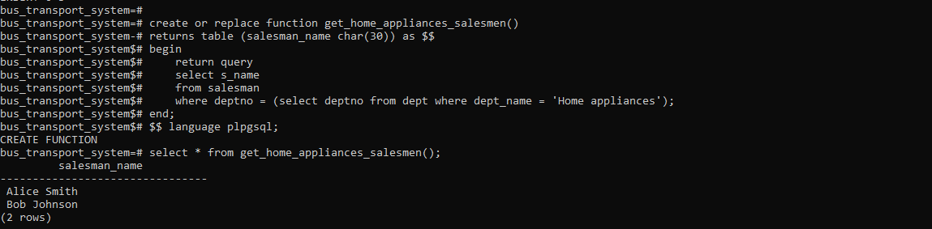

-- 2) function to find a business trip having maximum expenses
create or replace function getmaxtrip() returns text as
$$
declare fc text;
tc text;
begin
select from_city , to_city into fc,tc from trip natural join expense where amount = (select max(amount) from expense);
return fc || '' || tc;
end;
$$
language plpgsql;

select getmaxtrip();
getmaxtrip
----------------
DelhiBangalore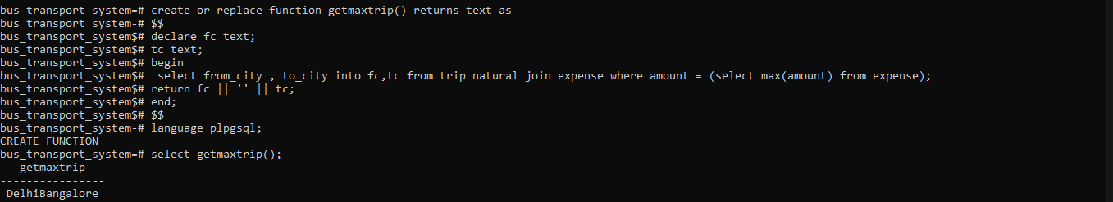

-- 3) function to count the total number of business trips from ‘Pune’ to ‘Mumbai’
create or replace function count_trips_from_pune_to_mumbai()
returns integer as $$
declare
trip_count integer;
begin
select count(*) into trip_count
from trip
where from_city = 'Pune' and to_city = 'Mumbai';
return trip_count;
end;
$$ language plpgsql;

-- to call the function:
select count_trips_from_pune_to_mumbai();

